Waltham-on-the-Wolds
Church of England Primary School


Parents Handbook 2025


“Let your light shine” Matthew 5:16
We hope you find the information enclosed helpful.
Should you require any further information please contact:
Neil Bardsley: Executive head
office@waltham.risemat.co.uk
Waltham-on-the- Wolds CE Primary School
Melton Road
Waltham-on-the-Wolds
LE14 4AJ
01664 464269


About the club
The CReW Club is a child-care provision that is based in the school hall. The club is open from
3.15pm until 6pm, Monday-Thursday, during term time.
We have outside areas that we can use such as a good sized playground, a large playing field and a wooded area at the bottom of the field.

Aims
At the CReW club we aim to provide a happy, safe, warm and stimulating environment for all children to play, learn and develop freely. We offer a range of activities that reflect the interests of the children in our care.
Where will it take place
CReW club is situated in the school hall.

What we offer
Our club offers a wide range of fun and exciting activities children can choose from, these include:
- Board games
- Construction activities
- Creative activities
- Small world toys
And so much more.
We also have a daily timetable of activities which are adult led for the children to enjoy, these include:
- Sports
- Music and dance
- Team games
- Movie nights
And many more.
We also offer themed activities, these include for example:

- Comic book club
- Forest exploration
- Lego Club
- Fun food

What we provide
A snack and drink will be available for all children at the start of our session. Children who are booked in after 4.15pm can also enjoy a snack tea at an extra cost of just £1.50.
We encourage the children at club to help out with tea, such helping to give out cups and clearing away their own dishes after tea. We use fresh ingredients and follow statutory guidelines. Fresh drinking water is always available. We meet individual children’s dietary requirements and parental preferences wherever possible. As a club we recognise the fundamental importance of a healthy nutritional diet for children which is delivered in a clam and friendly setting.

Staffing
The leader of the CReW Club is Mrs Sarah Dawson and the CReW Club assistant is Mrs Kay Burrows.
Overall responsibility: Mr Neil Bardsley, Executive Headteacher and Mrs Copeland and Mrs Pearson, Senior leaders.
All of our staff have significant experience of working with children and undertake professional development training. All staff members have had appropriate DBS checks.
If you have a query or concern at any time, please speak to a member of staff at club when you collect. If you would prefer to arrange a more convenient time for a meeting please contact the school office.

Organisation
The CReW Club is run as a non-profit organisation, employing two members of staff. We have a close working relationship with the primary school in order to ensure continuity of care, and to maintain good communication links.


Schools Policies and Procedures
The CReW Club has clearly defined policies and procedures. Copies of the policies and procedures are kept in the school office and are available for parents to consult at all times.

TERMS AND CONDITIONS

Admissions
The CReW Club aims to be accessible to all children that attend Waltham-on-the-Wolds CE Primary School and 4 year olds attending Waltham Pre-School. Admissions to the club are organised by the school office and the leader of club. The CReW Club requires a completed registration form and parental contract before children can attend.
This information will be treated as confidential and will be stored in the school office securely.

Payment of fees
The current fees for The CReW Club are:
3.15-4.15pm = £4.50 which includes a snack and a drink
3.15-5.15pm = £9.00 (£10.50 with a light tea)
3.15-6pm = £12.00 (with light tea)
Payment details are available on the booking forms.
The price per session per child applies to all children. This is payable for all booked sessions including when your child is sick, or on holiday. We do not charge for bank holidays or training days.
All payments must be paid in full for the current half term before your child attends.

Changes
Please remember that we need to know if your child will not be attending The CReW Club. Please contact the school office or inform the CReW Club staff when collecting.
If you know in advance of any days when your child will not be attending during the following week, please contact the school office or inform CReW Club staff as soon as possible. All contact details can be found on the front of this handbook.
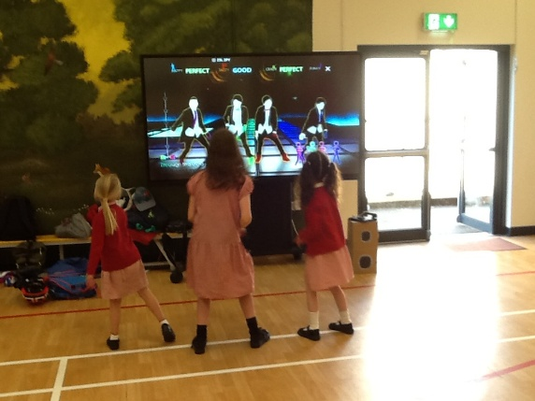

Arrivals and Departures
On arrival, a member of staff will immediately record the child’s attendance on the daily register on Arbor. All children will meet CReW Club staff on the playground at the end of school; pre-school children are brought up by a member of pre-school staff.
On departure parents/carers ring the doorbell outside of the hall and wait for a member of staff to answer. The gate to the hall is padlocked at all times. If a child is to be collected by someone other than the parent/carer, they must be informed of the password provided to CReW Club on the child’s registration form. Only adults aged 16 or over will be authorised to collect. If a password cannot be given then the CReW Club leader will telephone parent/carers. Upon departure the parent/carer will be asked to sign their child out on the daily register.
The Club finishes at 6pm, if you are delayed for any reason, please call the club to let us know; charges will apply, so please refer to our charging policy.
If your child remains uncollected after 6.10pm and you have not informed us of your delay, and we have not been able to reach you or any of your emergency contacts, we will follow the uncollected children policy and contact the social care team after 60 minutes.

Child Protection
We are committed to building a ‘culture of safety’ in which the children in our care are protected from abuse and harm. Any suspicion of abuse is promptly and appropriately responded to. We comply with local and national child protection procedures and ensure that all staff are appropriately trained. For more details see our Safeguarding and Child Protection Policy.

Equal Opportunities
Our Club provides a safe and caring environment, free from discrimination, for everyone in our community including children with additional needs.
- We respect the different racial origins, religions, cultures and languages in a multi-ethnic society so that each child is valued as an individual without racial or gender stereotyping.
- We will challenge inappropriate attitudes and practices.
- We will not tolerate any form of racial or sexual harassment. Refer to our Equalities policy for more information.

Special Educational Needs and Disabilities
- We make every effort to accommodate and welcome any child with special needs. We will work in
- liaison with parents or carers and relevant professionals to fully understand your child’s specific requirements. We will endeavour to accommodate all children of all abilities, whilst working within the Club’s limitations. Each case will be considered individually and risk-assessed to ensure everyone’s safety.

- Our staff training programme includes specific elements relating to children with special needs.
- For more details on equal opportunities and special needs, see our Policy section on the website.

GENERAL INFORMATION Behaviour (children)
- Children and staff follow the school rules for acceptable behaviour whilst at the Club.
- See the schools Behaviour and Attitudes Policy for full details.
- The Club promotes an atmosphere of care, consideration and respect for everyone attending:
children, staff and visitors.
- We encourage appropriate behaviour through: praise for good behaviour; emphasis on co-operative play and sharing; talking to children with the courtesy that we expect from them and engaging children in activities.
- The Club has procedures for dealing with unacceptable behaviour. We recognise that poor behaviour can occur from time to time for reasons that are not always evident, or as a result of special needs. We will try to be flexible in order to accommodate such cases.
- However, if your child is violent, or if their behaviour poses an immediate danger to themselves or others, we will require you to collect them from the Club immediately. In exceptional circumstances, and only when all other attempts at behaviour management have failed, we reserve the right to permanently exclude a child from the Club.

Behaviour (adults)
We will not tolerate from any person, whether a parent, carer or visitor: bullying; aggressive, confrontational or threatening behaviour; or behaviour intended to result in conflict. Our Club is a place of safety and security for the children who attend and the staff who work here, and we reserve the right to ban anyone exhibiting inappropriate behaviour from our premises.

Illness
We are unable to care for children who are unwell. If your child becomes unwell whilst at the Club, we will contact you and ask you to make arrangements for them to be collected.
Please inform a member of staff or the office administrator of any infectious illness your child contracts. If your child has had sickness or diarrhoea please do not send him or her to the Club for 48 hours after the illness has ceased.

Accidents and First Aid
Every precaution is taken to ensure the safety of the children at all times, and the Club is fully insured. Our staff are trained in first aid and a first aid kit is kept on the premises. If your child has an accident whilst in our care, you will be informed when you collect your child.

Medication
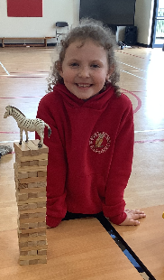
If your child needs to take medication while at Club you will need to complete the schools ‘Permission to administer medication’ form from the school office in advance. The Club leader will liaise before any medication is given

Complaints procedure
If you have any queries, comments or need to discuss any matters concerning your child, please feel free to speak to a member of our team. Verbal complaints will be brought to the next staff meeting for discussion and action. All written complaints will be acknowledged within 10 working days of receipt; please refer to the school Complaints Policy.

Privacy Notice
At the CReW Club we respect the privacy of the children attending the Club and the privacy of their parents or carers. The personal information that we collect about you and your child is used only to provide appropriate care for them, maintain our service to you, and communicate with you effectively. Our legal basis for processing the personal information relating to you and your child is so that we can fulfil our contract with you.
Any information that you provide is kept secure. Data that is no longer required* is erased/shredded after your child has ceased attending our Club.
We will use the contact details you give us to contact you via phone, email, class dojo and post so that we can send you information about your child, our Club and other relevant news, and also so that we can communicate with you regarding payment of our fees.
We will only share personal information about you or your child with another organisation if we:
- have a safeguarding concern about your child.
- are required to by government bodies or law enforcement agencies.
- engage a supplier to process data on our behalf (e.g. to take online bookings, or to issue invoices).
- have obtained your prior permission.

You have the right to ask to see the data that we have about yourself or your child, and to ask for any errors to be corrected. We will respond to all such requests within one month. You can also ask for the data to be deleted, but note that:
- we will not be able to continue to care for your child if we do not have sufficient information about them
- even after your child has left our care, we have a statutory duty to retain some types of data for specific periods of time* so can’t delete everything immediately.
If you have a complaint about how we have kept your information secure, or how we have responded to a request to access, update or erase your data, you can refer us to the Information Commissioner’s Office (ICO). Details on the Trust website.

* We do need to retain certain types of data (such as records of complaints, accidents, and attendance) for set periods of time after your child ceases to be in our care, but we delete as much personal data as we can as soon as possible.


PLEDGE TO PARENTS

We value our relationship with parents/carers and are committed to working in partnership with you to provide top quality play and care for your children. We will:
- Welcome you at all times to discuss our work, have a chat or take part in our activities.
- Keep you informed of opening times, fees and charges, programmes of activities, menus, and procedures.
- Be consistent and reliable to enable you to plan with confidence and peace of mind.
- Share and discuss your child's achievements, experiences, progress, and friendships.
- Be available to discuss decisions about running the Club.
- Ask your permission for outings and special events.
- Listen to your views and concerns to ensure that we continue to meet your needs.

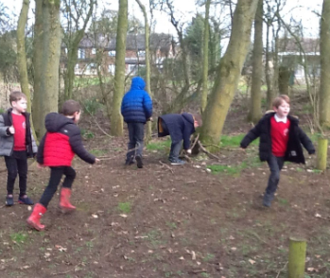

The CReW Club Team July 2025

