
Waltham-on-the-Wolds Church of England Primary School The CRεW Club
Before and After School Child Care
Booking Form Summer B 2026
Pupil Premium
Childs name: ______________________________________
Morning - 7.35 - 8.35 = £5.00 (including breakfast)
Afternoon - 3.15 - 4.15 = £4.50 (inc. drink and snack) | 3.15 - 5.15 = £9.00 (£10.50 inc. a light tea) | 3.15 – 6.00 = £12.00 (£13.50 inc. a light tea)
Please tick the sessions that you require.

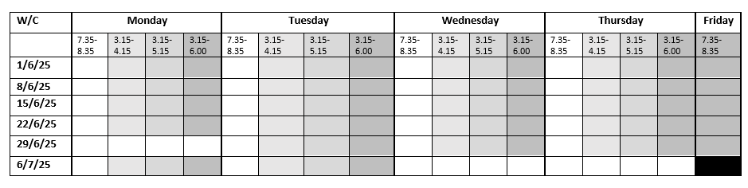

Please calculate the total cost of the sessions, pay the amount via childcare vouchers and then email the school office to advise of the payment. The school will then check the voucher account, add the credit to Arbor and manually add your child to the selected sessions on Arbor.
Please email/deliver to the school office: office@waltham.risemat.co.uk
Please book my child in for the days and times indicated above. I will let you know in advance if my child will not be attending a booked session.
I understand that the Club cannot give refunds.
Signed (Parent/Carer)___________________________________ Date__________________________________

